**Midsummer Park Pre-School**

**Parent Pack**



**Midsummer Park Pre-School**

**Our vision is to provide a high quality workforce to enable us to provide a**

**Safe, loving, homely, secure and stimulating environment for your children to learn to their very best ability through play.**

**We aim to make this journey through Pre-School as exciting and as enjoyable as possible. Working closely with parents/carers is paramount to getting the very best start to your child’s time with us.**

**Settling in Sessions**

**These sessions will enable you and your child/ren to:**

* **Experience the learning environment in small then increasing periods.**
* **Meet their new teachers and some of their peers in a smaller group.**
* **Creates a child centred approach that enables your child to gradually settle into Pre-school at their own pace.**
* **When your child sees you interacting with their Key-Person it shows them that you trust them.**

**Settling in sessions will look as follows:**

**Day 1 – Parent stay and play. (New Starters)**

**Day 2 – 1hr Settling in Session. (New Starters in staggered groups)**

**Day 3 – 1hr Settling in Session. (New Starters in staggered groups)**

**Day 4 – 2hr Settling in Session. (All Children)**

**Day 5 – 2hr Settling in Session. (All Children)**

*(Please remember some children may take longer to settle, so these shorter sessions may need to be extended until your child/ren is/are ready).*

**Supporting Children and families to settle – information for parents and carers**

1. **Building a warm, trusting relationship with your Key Person.**

**Children feel safe with people they know well and trust. So one of the best things you can do is help your child build a trusting relationship with their key-person. Here are some ideas:**

**Talk to your child about their special key person at home in the same way you talk about friends or your family. Say positive things and use their name. Use the photo of your child key-person as you talk about them.**

**Show your child that you trust the key person – for example, let your child see you talking comfortably with them.**

**Display photos of your child key person at home and give the nursery photos of you and of other significant members of your family so that they can talk about you/home with your child. You could put photos or some objects from home including something that smells of you (like a soft toy, a scarf or t shirt) in a box for your child so they can look at and think about you whilst they are in nursery. This helps your child emotionally as they settle in and can be of great comfort when they are distressed.**

**Walk past the nursery with your child before they start – perhaps you can see the front door and wave hello!**

**Talk to your child about their nursery – tell them what they will be doing there and what you think they might enjoy. Use photos of the setting to help.**

1. **Saying goodbye: tips to help your child settle at nursery.**

**Saying goodbye can feel hard for both you and your child at first. Try to acknowledge your child feelings, so that your child knows you are listening to them and that you do understand how they feel. For example, *“I know you feel sad. Its hard for you to say goodbye today”* it doesn’t help to say things *“don’t cry”* or *“don’t be upset”.***

**Talk together about an activity you and your baby will do together when you get home or when you come and pick them up, like playing together or reading a story.**

**A goodbye or hello ritual, like three kisses and a big hug or some other special thing that’s meaningful for your child.**

**Let your child know that you or another familiar grown-up will be back to pick them up at a particular time, or after an event that your child understands, like sleep or snack time.**

**Keep goodbyes brief – staying around in a ‘worried way’ can end up prolonging distress but make sure your key person is nearby to comfort your child when you go if you feel that need that support.**

**Phones away – Saying goodbye and saying hello are golden moments for connection. A distracting phone will get in the way of this special moment of parting or reunion so this is why we always ask for ‘no phones’ on site as well as for safeguarding reasons.**

**Be kind to yourself – Change is hard and starting childcare is a BIG transition for everyone so it is understandable if things feel hard whilst everyone adjusts.**

**1-How might my child’s behaviour change when they are settling?**

**Crying or clinging is NORMAL and healthy behavioural signs of separation anxiety which your child may display as they adjust to their new routine. Children communicate through their behaviour so, although thay may not yet be able to say directly that they are having a hard time adjusting to change, they will *show* you through changes in their behaviour. For example:**

* **They may be reluctant to go to sleep, wake in the night or have bad dreams.**
* **They may be more clingy and need more reassurance and cuddles and closeness than usual.**
* **They may seem overly bossy/cross and want to control what is happening more than usual.**
* **They may seem more fragile and tearful than usual about things they can usually manage.**
* **They may seem perfectly fine for the first few days but THEN start to show or tell you they don’t want to leave you.**
* **They may regress in how they want to play/talk – reverting back to old favourite books/toys/ways of being comforted.**
* **They may become ‘fussier’ about food and eating.**
* **They may have more tummy upsets, coughs and colds than usual.**
* **They may be quieter or more withdrawn than usual. Although these behaviours can feel hard for you and your child, all these behaviours are normal as children experience *any* big changes in their life. There is only a cause for concern if they don’t settle back down. More cuddles, comfort and understanding are usually all that is needed to help support them.**

**Lunch/Snack**

**We ask that all parents/Carers provide their child with a small lunch bag that is clearly labelled with their name with a choice of snack that they would like. For children that are attending all day they will also require lunch. You will not need to provide a drink as water and milk are available throughout the session.**

**We will encourage your child to come to the snack area when they feel they are hungry. We have our lovely snack supervisors Liz and Ellyse who supervise snack, encourage independence by teaching/assisting your child/ren to pour their own drinks and wash up their cups, learn about healthy eating and are there to have lovely interactions with your child/ren.**

**We are a healthy eating and nut free setting and must insist on healthy snacks and lunches only.**

**Types of foods we allow are:**

* Fruits and vegetables (No raisins).
* **Rice cakes**
* **Crackers**
* **Sandwiches (No chocolate spread or peanut butter)**
* **Yoghurt**
* **Bread sticks**
* **Cheese**
* **Salads**
* **Rice**
* **Pasta**
* **Wraps**



**Doctors warn that food is responsible for over half of all fatal choking accidents, with grapes the third most common cause of death in food-related incidents.**If you are providing grapes/tomatoes/berries for your child/rens snack and/or lunch please can you follow the following guidelines:

**Our Routine**

Seedling Room Flower Room

**8.30a.m. Children arrive 9a.m. Children arrive**

**8.30a.m – 11.40a.m. Teeth Brushing 9a.m. – 11.35 Teeth Brushing**

**Child led & Child led &**

**planned activities planned activities**

**Snack Snack**

**Small Group time Small Group Time**

**11.40a.m. - 11.50a.m. Tidy up time 11.35a.m. – 11.40a.m. Tidy up Time**

**11.50a.m. – 12.05p.m. Outdoor Physical activity 11.40a.m. – 11.50a.m. Outdoor physical**

**12.05p.m. – 12.15p.m. Story Time activity**

**12.15p.m. Home Time 11.50a.m. – 12p.m. Story Time**

**12p.m. Home Time**

**When your Child comes home messy**

***When your child comes home messy* with …Paint in their hair! Glue on their jeans!, Sand in their shoes!, Food on their best shirt!, White socks that look brown!, Sleeves a little damp!**

**YOUR CHILD PROBABLY …worked with a friend, solved a problem, created a masterpiece, negotiated a difference, learned a new skill, had a great time developing new language skills.**

**YOUR CHILD PROBABLY DIDN’T… feel lonely, become bored, do repetitive tasks or worksheets, and sit down to work that is discouraging.**

**YOU PROBABLY… paid good money for all them clothes, will have trouble getting the paint out, are concerned that we are not paying enough attention to your child.**

**YOUR CHILDS KEYWORKER is probably… aware of your child’s needs and interests, spent time planning a challenging activity for the children, encouraged the children to try new things, was worried that you might be concerned.**

**Try to remember your favourite activity when you were little. Was it outdoor play?, play with water?, dressing up clothes, with friends?**

**Young children really learn when they are actively involved in play, not when someone is controlling their play. There is a difference between ‘messy’ and ‘lack of care’. We made sure your child was fed, warm, washed hands after toileting and before eating, and also planned messy fun things to do because that’s *How young children learn!***

**Send your child/ren in clothes that can get dirty! Send extra old clothes for times when your child gets wet or really messy.**

**Stay Calm… Remember in a few years, as teenagers your child will probably use your shampoo, your favourite bath toiletries and most of your towels to be clean. But young children need time to just be themselves…children!**

**Recording Progress**

**Each Childs progress will be tracked throughout the year and will be documented on our Early Years Individual Progress Tracker (see below right).**

**We use an online system called EYLOG where photos, videos and/or audio recordings will be added to create a special record of your child’s development and experiences not only by us but you too. Working in partnership with parents is very important to us.**

**EYLOG is a vital tool to inform you of any changes, holiday dates, information, school closures etc that you need to know so it is *extremely important!* that once you receive an email from EYLOG you activate your account and keep up to date with any messages sent to you.**

**



**We work with super star sport to create and maintain a sporting culture of which we are proud of. Once a week a coach attends our setting and provides a fun, enthusiastic, positive, high energy session which inspires children to fall in love with sports and exercise, all for just £1 p/w this can either be paid in cash or via bank transfer.**

What does my child need to start Pre-School?

* Old Clothing-(Your child will get messy)
* Nappies and wipes-(If required)
* Spare clothes
* Weather appropriate clothing e.g. Wellies, waterproofs, sun hat (we are a free flow setting, there are a vast amount of learning experiences which happen outdoors. *(There is no such thing as bad weather just bad clothing*)
* Healthy Lunch and/or snack (no drink needed. We provide both water and milk)

* **Please be on time to drop of and collect your child/ren to avoid upset and disruption. If you are going to be late please call to let us Know so we can prepare your child/ren.**
* **If your child/ren are going to be absent please ensure that you call us in the morning to notify us. If we do not hear from you there are procedures we have to follow:**
* ***We will call parents to ascertain the reason for absence.***
* ***If we cannot contact parents we will call emergency contacts.***
* ***If we still cannot ascertain reason for absence we will do a home visit.***
* ***If we still have had no contact we will then have no other option other than to call the police to ensure the child/rens safety.***
* **(As you can appreciate this does take a lot of staffs time, so please ensure you notify us of any absences)**
* **Unfortunately our car park is strictly for Pre-School and Children Centre staff only. It is only a small area, parking and congesting the area without permission can cause members of staff to be late which in turn causes disruption to the setting and can delay opening times, it can be extremely dangerous for children and in the unforeseen event that emergency services need to be called without nowhere for them to park it will cause a delay in them getting to us. Please be mindful of this and only park in the car park if you have had permission from a member of staff.**

**Meet Our Staff**

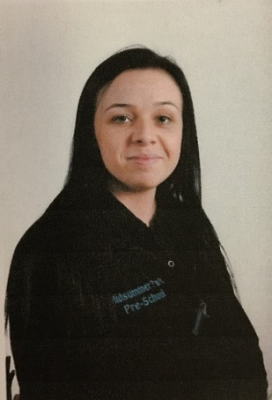

**Kerry Champion**

**Co-Owner**

**Sarah Knights**

**Manager**

**Gina Collett**

**Deputy Manager**

**Ailish Creighton**

**SENCO**



**Natalie Grabban**

**Room Leader**

**Flower Room**

**Sonia DaCosta**

**Room Leader**

**Seedling Room**

**Meet our Staff**

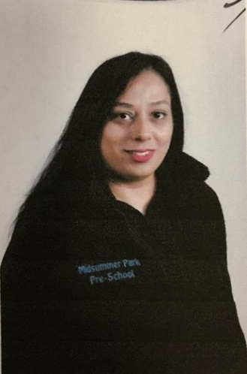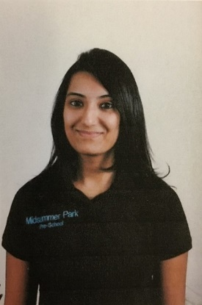

**Stacey Smith**

**Early Years Educator**

**Suki Bhatti**

**Early Years Educator**

**Preenal Shah**

**Early Years Educator**

**Coral Stygal**

**Early Years Educator**

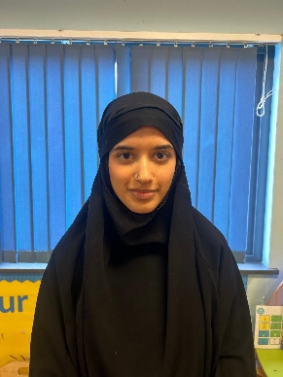

**Maria Gray**

**Early Years Practitioner**

**Emily Bratti**

**Early Years Educator**

**Hanifa Maryam**

**Student (working towards L3)**

**Shifa Ali**

**Student (working towards L3)**

**Meet Our Staff**

**Hasiba Sammie**

**Pre-School Assistant**

**Liz Hodgson**

**Snack Supervisor**

**Ellyse Humphreys**

**Snack Supervisor**